Presentation Title

Author names with first as the presenting author
Author affiliations with corresponding author marked with *

* Corresponding author: (please inset email address here)

Abstract
Please add a brief 1-2 sentences about your research background and motivation. Then include a short summary of your results and discussion and important conclusions. Please keep it concise and the word count should be less than 200 words.
Please note:
- You can include one image (maximum) if necessary.
- You can include 1-2 references if needed.
- Please don’t change the margins and text font style and size.
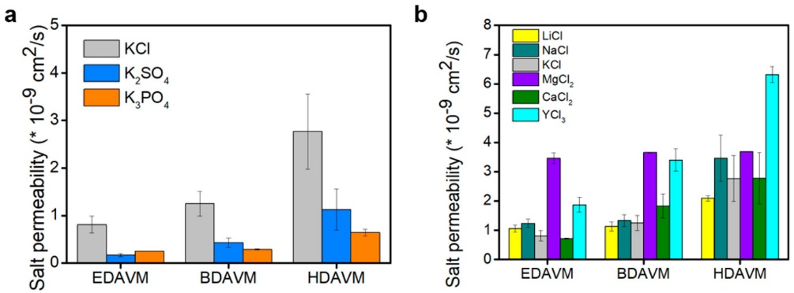

Figure 1. Salt permeability comparison. (a) Tunable anion permeability through xDAVMs. (b) Tunable cation permeability through xDAVMs.

References
Xia, Z.; Chen, W.; Shevate, R.; Wang, Y.; Gao, F.; Wang, D.; Kazi, O. A.; Mane, A. U.; Lee, S. S.; Elam, J. W., Tunable Ion Transport with Freestanding Vermiculite Membranes. ACS nano 2022, 16 (11), 18266-18273.

